Vidyavardhaka College of Engineering

An Autonomous Institute affiliated to VTU, Belagavi


Report On

« DAA OPEN ENDED EXPERIMENT »
Submitted by,

USN | NAME
4VV23CS137 | MONIKA KR
4VV23CS142 | NISCHALA KN

Course Name: DESIGN AND ANALYSIS OF ALGORITHM

Course code: BCSDA402

Prof. Chaya Kumari H A Assistant Professor, Dept. of CSE

Job Sequencing Problem

Introduction
Job Sequencing is a scheduling problem where we are given a set of jobs, each with a profit and a deadline. The goal is to determine the optimal sequence of jobs to maximize the total profit, subject to constraints such as job deadlines and available time slots.

Key Concepts in Job Sequencing
Each job in the sequencing problem is characterized by the following attributes:
- Profit: The amount of profit gained when the job is successfully completed.
- Deadline: The time by which the job must be finished to be considered valid
- Time Requirement: Each job takes exactly one unit of time to complete.

Objective
Select a sequence of jobs such that the total profit is maximized, and no jobs exceed their deadlines. Each job takes one unit of time, and the schedule must fit within available time slots.

Types of Job Sequencing Problem
- Greedy Method: Sort jobs by profit and assign to the latest available slot before the deadline.
- Job Sequencing without Deadlines : There are no deadlines, and the goal is to maximize profit by selecting jobs that fit within a given time frame.
- Job Sequencing with Constraints : Involves additional conditions such as job dependencies or priority rules, requiring more complex scheduling logic.

Approaches to Solving Job Sequencing Problems
- Greedy Method: Sort jobs by profit and assign to the latest available slot before the deadline.
- Brute Force: Evaluate all possible job orders for feasibility and profit; computationally intensive.
- Dynamic Programming: Handles complex cases with varying durations or additional constraints.

Greedy Method: Code and Explanation
The greedy approach sorts jobs by profit and assigns each job to the latest available slot before its deadline, ensuring high-profit jobs are prioritized .
CODE
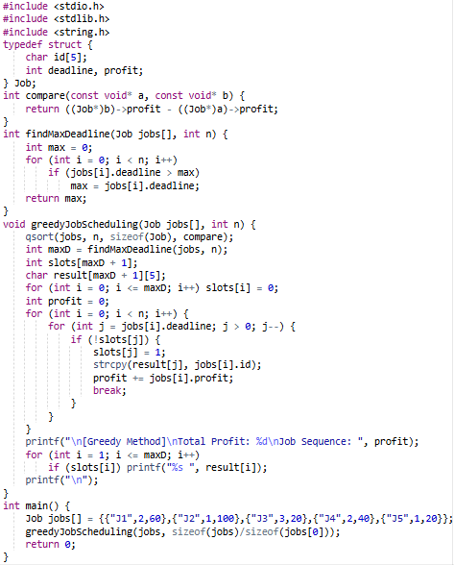
OUTPUT
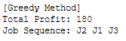

Brute Force Method: Code and Explanation
This method checks all permutations of jobs and retains the sequence with the highest feasible profit. It's accurate but only practical for small job sets.
CODE
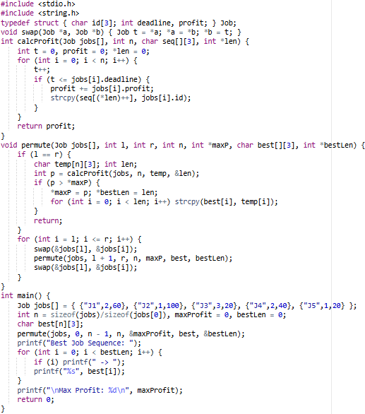
OUTPUT
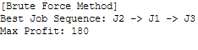
Comparison: Greedy vs Brute Force

Greedy Method
- Approach: Selects jobs based on highest profit.
- Time Complexity: O(n log n) (due to sorting).
- Optimality: Usually optimal or near-optimal.
- Efficiency: Fast and efficient even for large inputs.
- Implementation: Simple and easy to implement.
- Scalability: Highly scalable.
- Use Case: Practical real-world applications.

Brute Force Method
- Approach: Tries all possible job sequences.
- Time Complexity: O(n!) (factorial time).
- Optimality: Always finds the optimal solution.
- Efficiency: Very slow for large inputs.
- Implementation: Complex due to permutations.
- Scalability: Poor scalability.
- Use Case: Theoretical or very small input sizes.

Which Method is Better and Why?
The Greedy method is preferred for job sequencing due to its O(n log n) time complexity, making it faster and more efficient for large inputs. The Brute Force method, with O(n!) complexity, becomes impractical as the number of jobs increases, making Greedy more scalable and practical.
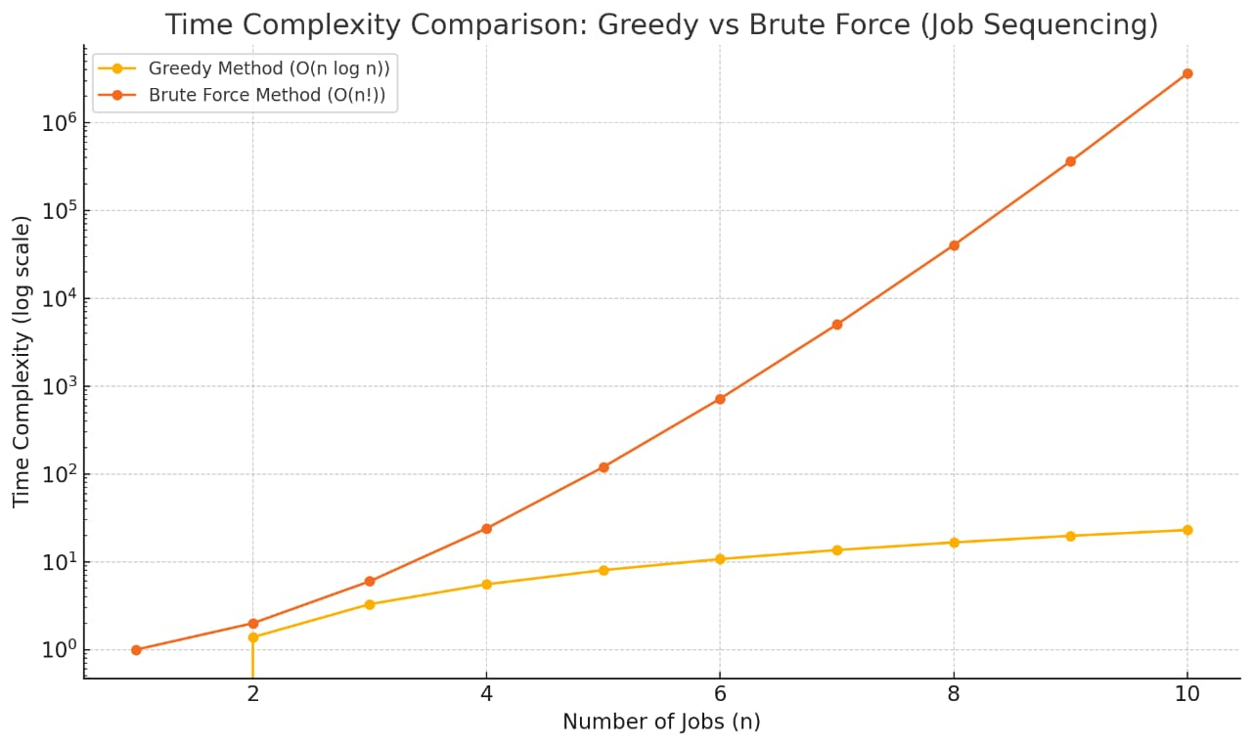

Conclusion
Job Sequencing is a core problem in optimization. The greedy method is the preferred approach in most real-world cases due to its balance of speed and effectiveness. Brute force remains a valuable educational tool and verifier for small datasets.

